Experiment: 6 5G NR Frame Structure Analysis with Different Subcarrier Spacing
AIM :To analyze the 5G NR frame structure by studying the effect of different subcarrier spacings, slot durations, and OFDM symbols using MATLAB.
Objective 1:
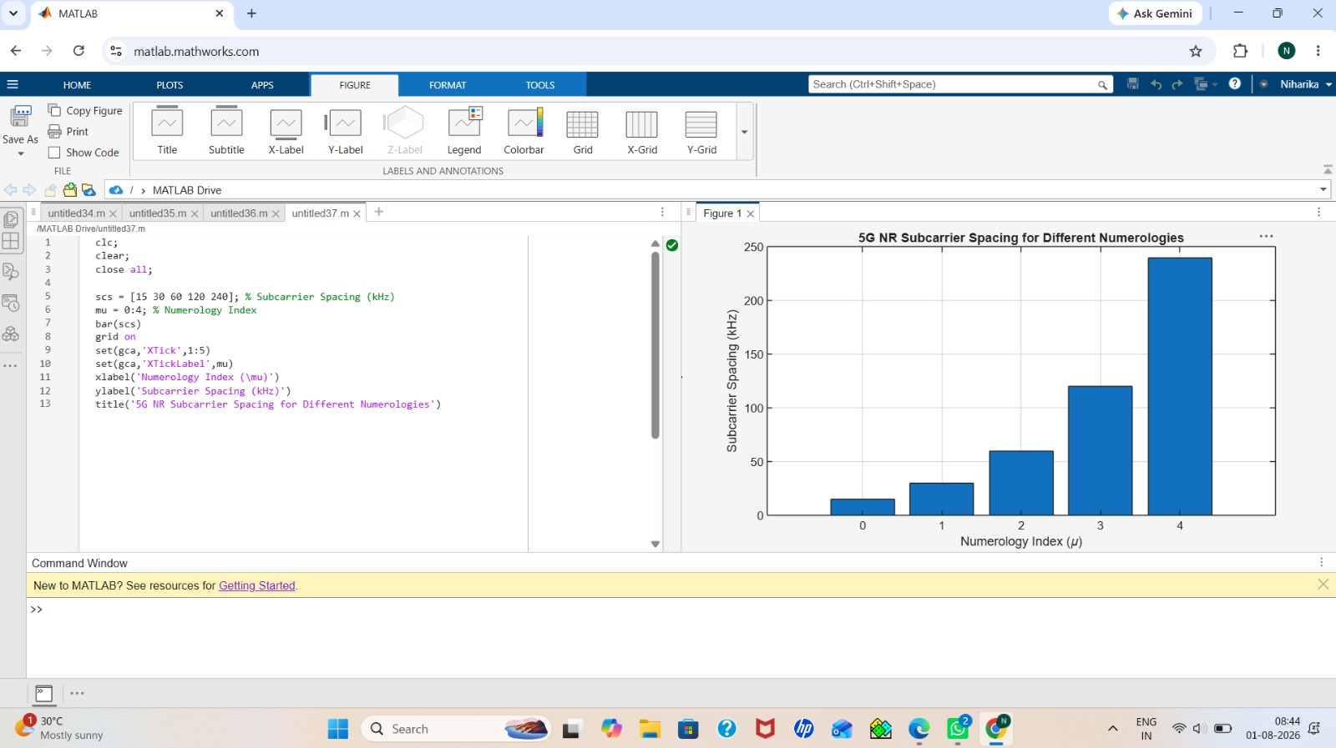
Objective 2: 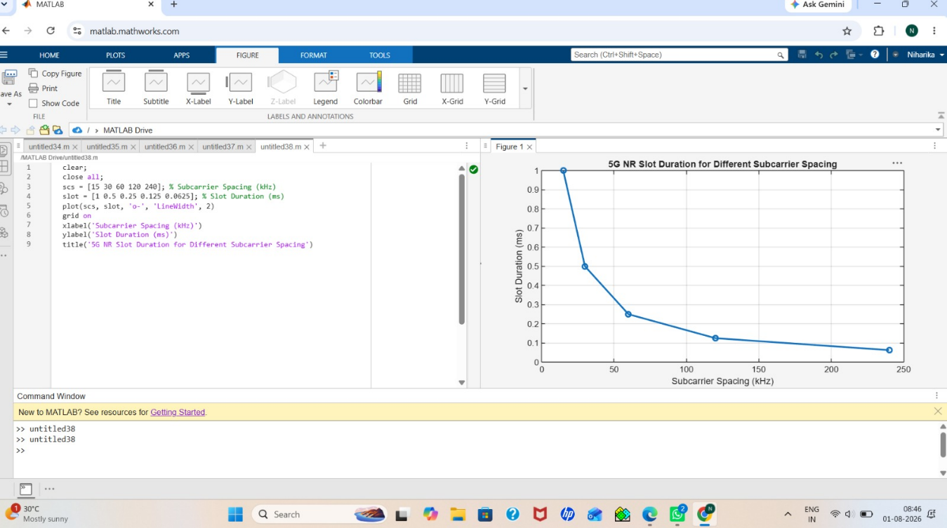
Objective 3:
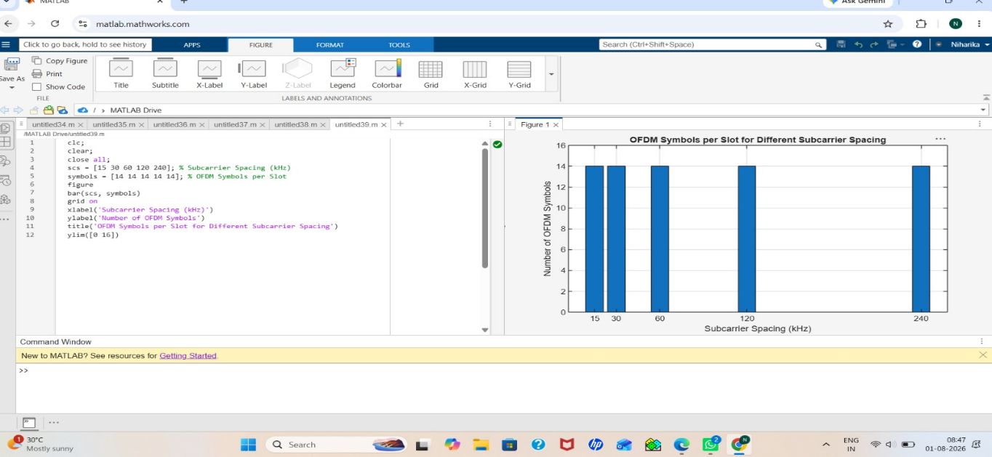
Result
The MATLAB analysis successfully demonstrated the flexible numerology of 5G NR. The results showed that increasing the subcarrier spacing decreases the slot duration while maintaining a constant number of OFDM symbols per slot under the normal cyclic prefix configuration.

